## A.2 Individual Inspection 2

|  |  |  |  |  |
| --- | --- | --- | --- | --- |
| **Inspector:** Luca Minotti | | | | |
| **Heuristic Type** | **Heuristic** | **Score** | **Comment** | **References** |
| Nielsen | Visibility of system status | 1 | Breadcrumbs do not clearly show where the user is in the website hierarchy. Their implementation is extremely counterintuitive. | Screenshot 2. 1 |

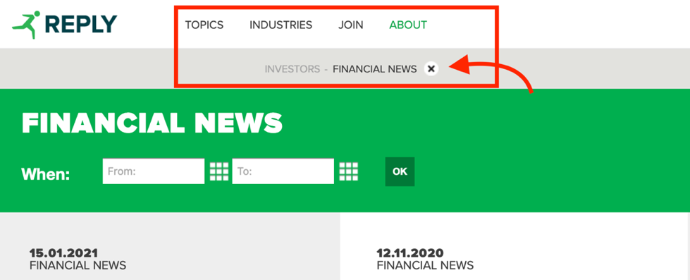

Screenshot 2. 1: <https://www.reply.com/en/investors/news>

|  |  |  |  |  |
| --- | --- | --- | --- | --- |
| **Heuristic Type** | **Heuristic** | **Score** | **Comment** | **References** |
| Nielsen | Match between system and the real world | 3 | The system mainly uses words familiar to the user. However, several pages of the website as well as the navigation bar, the search bar and error messages are shown in English regardless of the language chosen by the user. | Screenshot 2. 2  Screenshot 2. 3 |

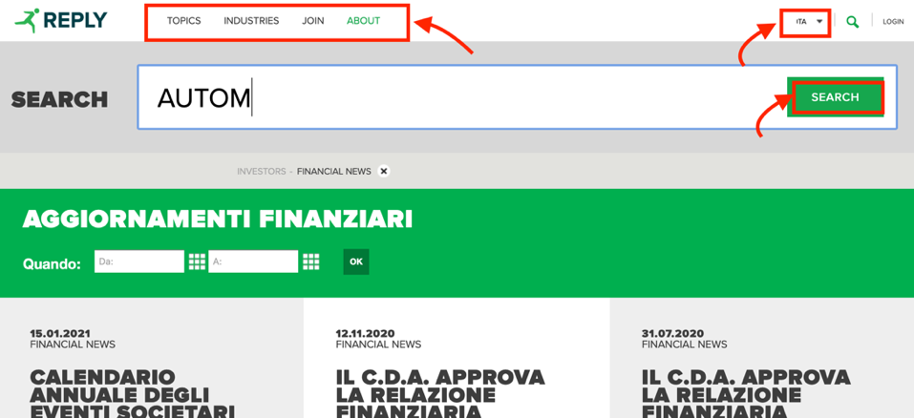

Screenshot 2. 2: <https://www.reply.com/it/investors/notizie>

Screenshot 2. 3: <https://www.reply.com/it/filenotfound>

|  |  |  |  |  |
| --- | --- | --- | --- | --- |
| **Heuristic Type** | **Heuristic** | **Score** | **Comment** | **References** |
| Nielsen | User control and freedom | 5 | Where applicable, the user always has the possibility to modify a previous choice without having to start over. For example, when filtering the upcoming events, the user always has the possibility to modify a wrong choice of the date range. | Screenshot 2. 4 |

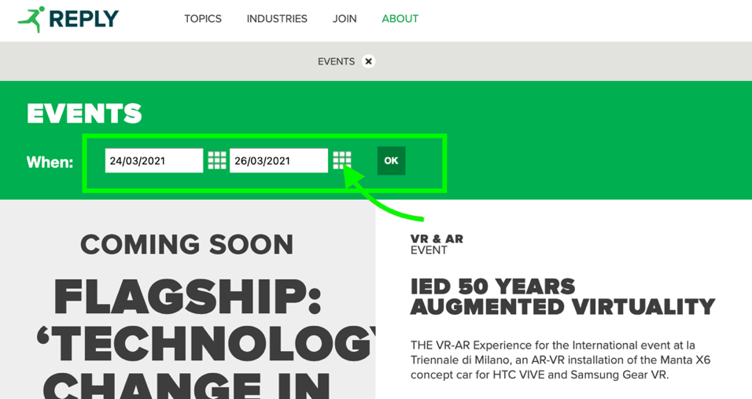

Screenshot 2. 4: <https://www.reply.com/en/newsroom/events>

|  |  |  |  |  |
| --- | --- | --- | --- | --- |
| **Heuristic Type** | **Heuristic** | **Score** | **Comment** | **References** |
| Nielsen | Consistency and standards | 5 | The website is consistent in the terminologies used and adheres to design standards (e.g., login button at the top right, standard icons for searching, sharing and closing pop-up windows, burger menu for the mobile version) | Screenshot 2. 5 |

Screenshot 2. 5: <https://www.reply.com>

|  |  |  |  |  |
| --- | --- | --- | --- | --- |
| **Heuristic Type** | **Heuristic** | **Score** | **Comment** | **References** |
| Nielsen | Error prevention | 3 | The system correctly requests confirmation to carry out some operations that the user may incorrectly select, such as deleting the account. However, sections such as the registration one need significant improvements (here the user has no way of knowing the password security requirements before submitting the form). | Screenshot 2. 6  Screenshot 2. 7 |

Screenshot 2. 6: <https://www.reply.com/en/userprofile>

Screenshot 2. 7: <https://www.reply.com/en/register>

|  |  |  |  |  |
| --- | --- | --- | --- | --- |
| **Heuristic Type** | **Heuristic** | **Score** | **Comment** | **References** |
| Nielsen | Recognition rather than recall | 2 | The system does not provide any suggestions for filling in some fields during registration or when searching the site using the appropriate function. | - |
| Nielsen | Flexibility and efficiency of use | 4 | Heuristics satisfied when applicable. For example, the system allows the insertion of dates both through the text boxes (inexperienced user) and through the calendar icon (accelerator for expert user). However, some flexibility improvements can be made. For example, when searching for a webinar, the search form does not allow you to select dates in the past. To view past webinars you need to visit another section, which is counterintuitive. | Screenshot 2. 8  Screenshot 2. 9 |

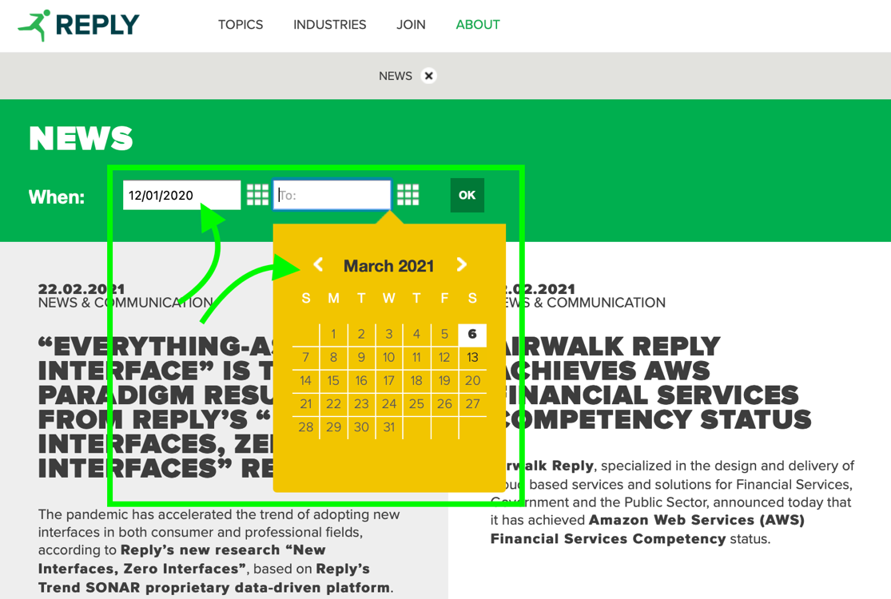

Screenshot 2. 8: <https://www.reply.com/en/newsroom/news>

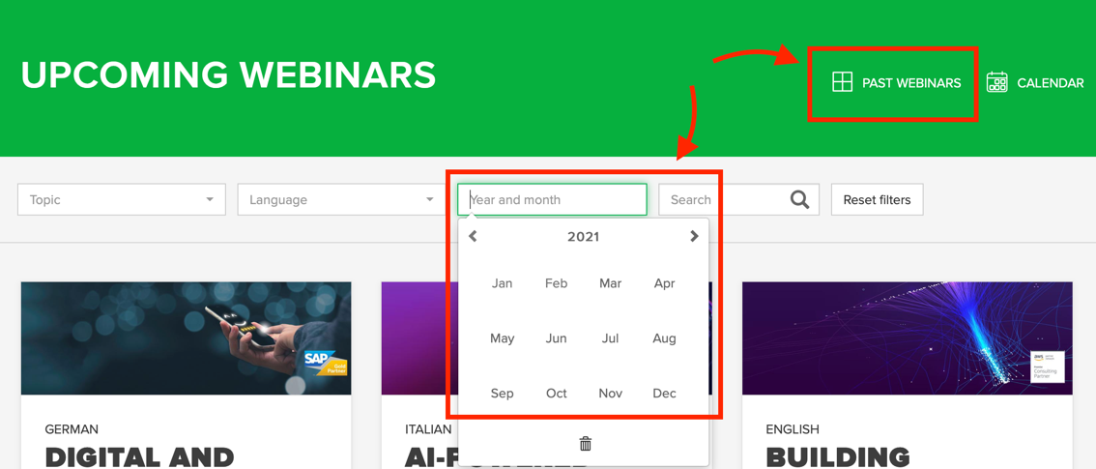

Screenshot 2. 9: <https://webinars.reply.com/>

|  |  |  |  |  |
| --- | --- | --- | --- | --- |
| **Heuristic Type** | **Heuristic** | **Score** | **Comment** | **References** |
| Nielsen | Aesthetic and minimalist design | 2 | The homepage shows too much information making it difficult to find what you are interested in. Even the menu items (e.g., Topics) in the top bar are too many and are not organized into further sub-categories, causing confusion. | Screenshot 2. 10 |

Screenshot 2. 10: <https://www.reply.com/en/>

|  |  |  |  |  |
| --- | --- | --- | --- | --- |
| **Heuristic Type** | **Heuristic** | **Score** | **Comment** | **References** |
| Nielsen | Help users recognize, diagnose and recover from errors | 1 | Some errors such as the page not found error are accompanied by a short explanation message, while others simply show a code and give no indication of what went wrong. | Screenshot 2. 11 |

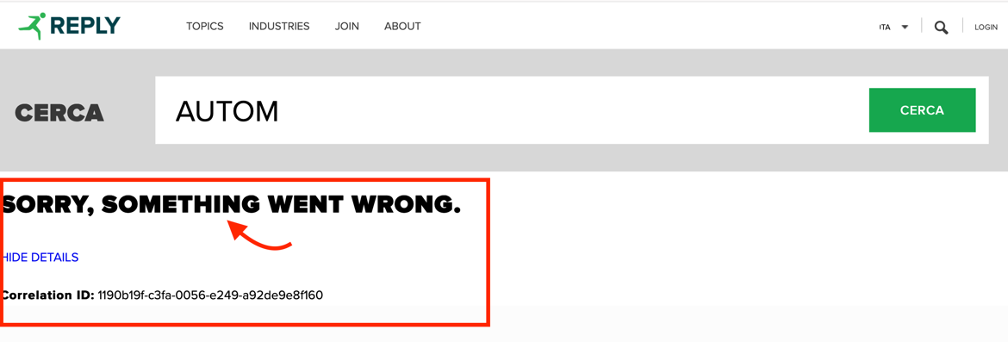

Screenshot 2. 11: <https://www.reply.com/en/search>

|  |  |  |  |  |
| --- | --- | --- | --- | --- |
| **Heuristic Type** | **Heuristic** | **Score** | **Comment** | **References** |
| Nielsen | Help and documentation | N/A | - | - |
| MILE Navigation | Interaction consistency | 4 | Almost satisfied. However, some case study articles open as a pop-up, while others open as a new tab | - |
| MILE Navigation | Group navigation | 0 | To move from one article to another or from one topic to another, the user must start over, making navigation difficult. Breadcrumb also do not provide any useful action to go back. | Screenshot 2. 12 |

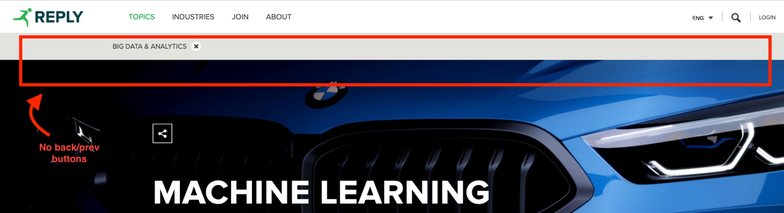

Screenshot 2. 12: <https://www.reply.com/en/topics/>

|  |  |  |  |  |
| --- | --- | --- | --- | --- |
| **Heuristic Type** | **Heuristic** | **Score** | **Comment** | **References** |
| MILE Navigation | Structural Navigation | 3 | The problems are concentrated in the homepage of the website and in the Investors section: too many components make it difficult to navigate between them and easily find what you are looking for. | Screenshot 2. 13 |

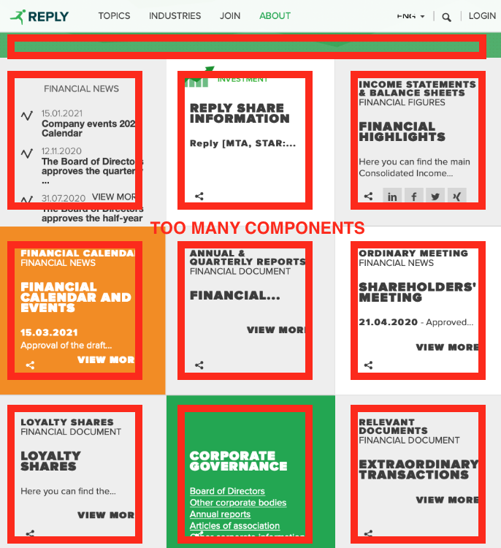

Screenshot 2. 13: <https://www.reply.com/en/investors/>

|  |  |  |  |  |
| --- | --- | --- | --- | --- |
| **Heuristic Type** | **Heuristic** | **Score** | **Comment** | **References** |
| MILE Navigation | Semantic Navigation | 4 | Some articles are accompanied by a sidebar that shows some related topics. However, this useful function is not available for all the articles. | Screenshot 2. 14 |

Screenshot 2. 14: <https://www.reply.com/en/content/timmusic-is-available-everywhere-at-any-time-on-any-device>

|  |  |  |  |  |
| --- | --- | --- | --- | --- |
| **Heuristic Type** | **Heuristic** | **Score** | **Comment** | **References** |
| MILE Navigation | Landmarks | 5 | Landmarks correctly provide useful access points to the main components of the website. | - |
| MILE Content | Information overload | 1 | The homepage and navigation drop-down menus show too much information making it easy to get lost. The information load is instead balanced in the various subsections (e.g., Topic). | Screenshot 2. 15 |

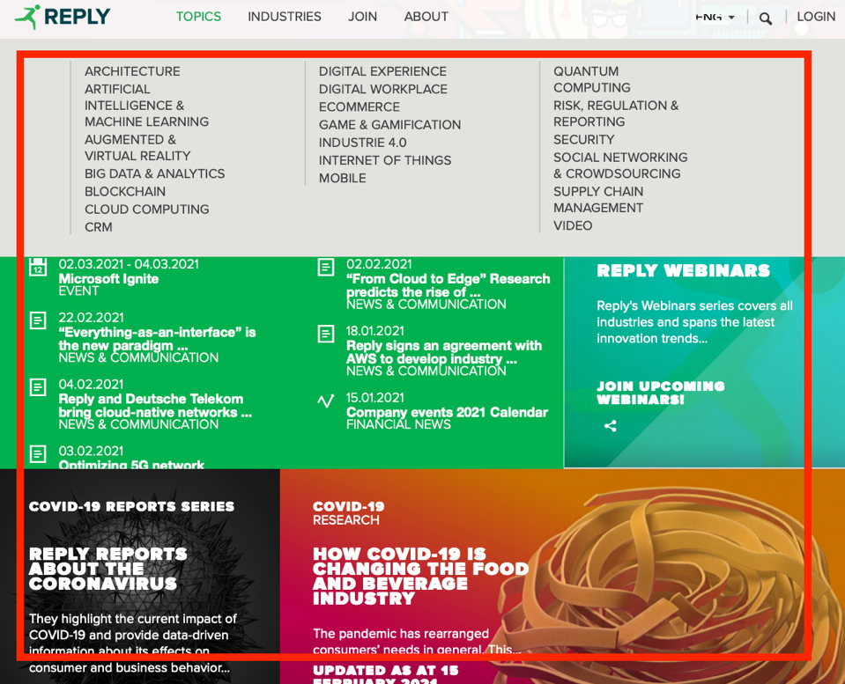

Screenshot 2. 15: <https://www.reply.com>

|  |  |  |  |  |
| --- | --- | --- | --- | --- |
| **Heuristic Type** | **Heuristic** | **Score** | **Comment** | **References** |
| MILE Presentation | Text layout | 5 | The text is always clearly readable. | - |
| MILE Presentation | Interaction placeholders-semiotics | 5 | No anomaly detected. | - |
| MILE Presentation | Interaction placeholders-consistency | 5 | No anomaly detected. | - |
| MILE Presentation | Spatial allocation | 5 | No anomaly detected: good spatial allocation. | - |
| MILE Presentation | Consistency of Page Structure | 2 | Almost all the main pages of the website share the same basic structure. However, many articles often have totally different structures: some are shown as pop-ups, others as stand-alone pages despite dealing with the same type of information. The different structure (Screenshot 23) causes a sense of disorientation in the user. | Screenshot 2. 16 |

Screenshot 2. 16: <https://www.reply.com/en/topics/artificial-intelligence-and-machine-learning/>